Continue with Wiring of Robotic Car

Run RobotUnderCurses.py

[python codes\ExplainingCurses.py](python%20codes/ExplainingCurses.py)

<cursesexplanation.pptm>

[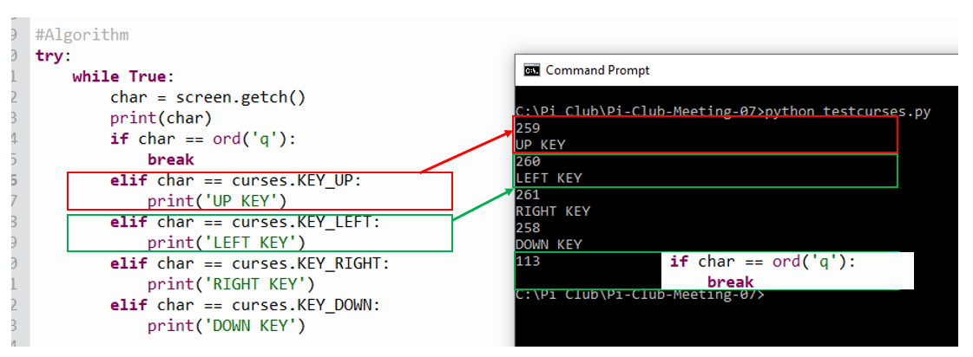](cursesexplanation.pptm)

Simulation of Robot Control - Wiring Diagram [Here](Wiring%20Diagram%20LED%20for%20testing%20curses.docx) (Page 1 of handout)

to get a better understanding of controls

Wiring up the Robotic car

L298N Wiring.ppt

Robot Car Wiring.docx

Test cursingrobby.py <cursingrobby.py>

Exercise to make robby do specific task – Page 3 of handout